Step by Step Instructions for Reference Writers

[You can get this file by clicking on the icon above on the “Refs” page after login as a reference writer. Click on the [doc] link if you want to save it as a Word file so you can edit and keep locally. Please email your corrections or updates to us.]

To upload a reference letter for an applicant, you should have already received a reference letter request email similar to this sample:

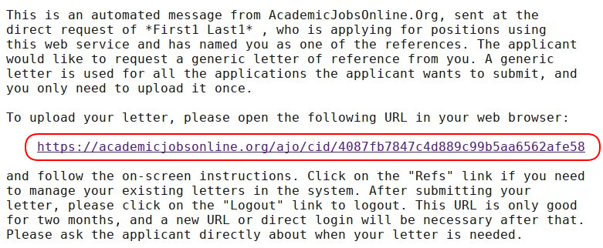

When you are ready to upload the letter, please open the URL in the email in a web browser to go
directly to the letter uploading form:

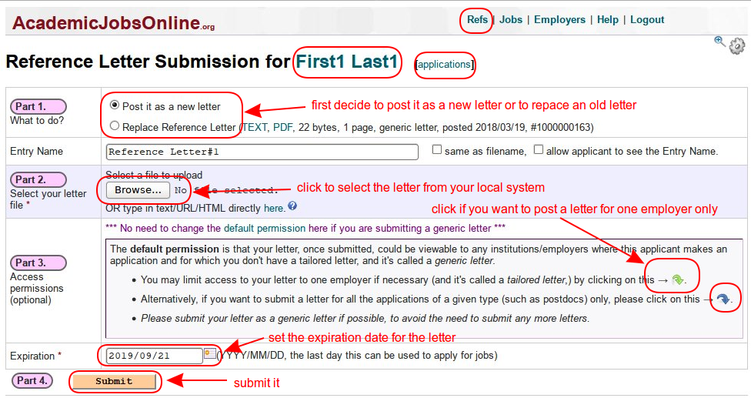
On this form, you first need to decide whether to upload the letter as a new letter or to replace an existing one. Please don’t replace any letters which are still in use, for example, don’t replace a tailored letter for some employer if that application is still active. Next click on the “Browse” or “Choose File” button to select the file for your letter from your local system. If this letter is to be used for all the applicant’s applications (a generic letter), you can just press “Submit” button to submit it. If it’s a letter for one employer (a tailored letter), please click on the green arrow to select the employer first. Once it’s submitted, you’ll see:

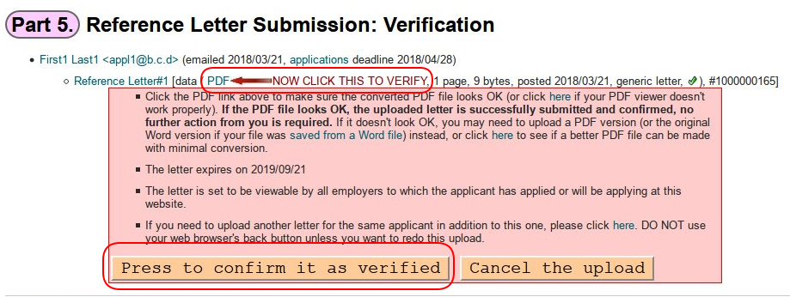

Here you can click on the “PDF” link to review the letter to make sure it looks right. Once that’s done, please click on “Press to confirm it as verified” to finish it.

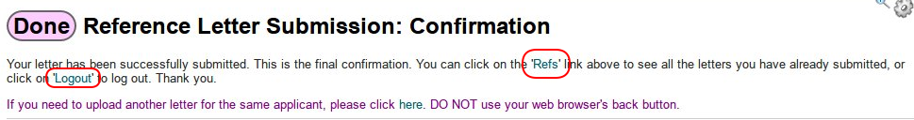

That’s all you need to do to upload a letter. You can click on the ‘applications’ link to see the list of active applications this applicant currently has and the letter each application uses. Click on the “Refs” link if you want to review all your letters or work on them directly. Click on “Logout” to log out your account.

FOR HELP:

For FAQs please log into AJO and click FAQs under the Help menu (https://academicjobsonline.org/ajo/faqs/10)

For other user documentation click User Guide under the Help menu (https://academicjobsonline.org/help/academicjobs/userdoc/)

You can always submit a help request to support@academicjobsonline.org

